Deep Learning-Based Workers Safety Helmet Wearing Detection on Construction Sites Using Multi-Scale Features

Alternate title:
Safety Helmet Detection using Deep Learning
Aim:
Our aim is to detect the worker helmet detetion using Faster RCNN
Abstract:
Due to a lack of knowledge about safety helmets, accidents and injuries on construction sites are now increasingly common. Worker supervision by hand is challenging and ineffective. Workers often take off the helmets because of weak security-conscious and discomfort, then hidden dangers will be brought by this behaviour.Workers without safety helmets will suffer more injuries in accidents such as falling human body and vertical falling matter. Hence, detecting safety helmet wearing is a vital step of construction sites safety management and a safety helmet detector. However, traditional manual monitor is labour intensive and methods of installing sensors on safety helmet are difficult to popularize.This study is visually checking the construction site to see if anyone is wearing a safety helmet. In order to recognise a safety helmet in real time at a building site, we built a deep learning-based technique.
Synopsis:
In the field of object detection, a series of methods based on deep learning were developed, and convolution neural networks (CNNs) are most commonly used because of their superiority in high-level feature extraction. The development of CNN-based detectors has motivated deep learning-based safety helmet wearing detection methods, and many researchers considered deep learning-based methods as a vital measure to deal with the construction safety management issue. We have used Faster RCNN to detect the helmet.

Existing System:
In existing paper, YOLOv3 has been used to detect the project. In YOLOv3, Darknet53 is used as the backbone to extract features from an input image. YOLOv3 is faster but the accuracy of YOLOv3 is low due to YOLOv3 using Darknet53 which struggles in detecting small objects.
Problem Definition:
The problem is to detect the helmet accurately. The accuracy of detecting helmet is low so, we need to improve the accuracy to enhance performance.
Proposed System:
In existing YOLOv3 can struggle to accurately detect small objects in images due to its single-stage detection pipeline. Faster R-CNN overcomes this issue by using a two-stage pipeline that first proposes regions of interest (ROIs) and then applies object detection within each ROI.
In existing YOLOv3 is highly efficient on small to medium-sized datasets, it can struggle with larger datasets due to the limitations of its single-stage detection pipeline. Faster R-CNN is better suited for larger datasets as it can handle more complex object detection tasks with higher accuracy.
Advantage:
The key advantages of using Faster R-CNN for helmet detection are its ability to handle object detection tasks and its efficiency in processing images. The region proposal network (RPN) component of the algorithm effectively generated region proposals, allowing the model to focus on potential helmet regions, thus reducing computational complexity. Additionally, the use of a convolutional neural network backbone (such as ResNet) facilitated feature extraction, enabling the model to learn discriminative features for helmet detection.
Algorithm:
After preprocessing dataset, that data will be given to the deep learning algorithm. Faster R-CNN (Region-based Convolutional Neural Network) is a two-stage object detection algorithm that first proposes regions of interest (ROIs) using a separate network (called a region proposal network) and then uses a CNN to classify and refine the ROIs.

Architecture Diagram:
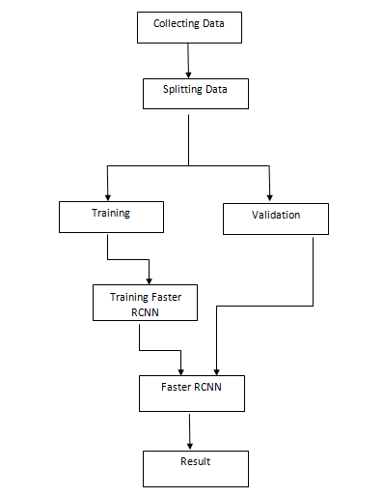

Moduels:
The project has been implemented by dividing the entire project into three modules.
- Data Collection
- Data Pre-processing
- Detection Of Helmet

Dataset Collection:
In this module we are collecting face dataset for face recognition for every person images to train the model. Data collection is the process of gathering information on specific areas with the aim of evaluation.

Data Preprocessing:
In this module we are applying different image augmentation steps to the image. Data preprocessing it is very important and time-consuming part of data analysis

Detection of Helmet:
To design and develop an approach using Deep learning classifiers for helmet detection. We have studied various models which are used for detection of helmet, based on the findings and results we have concluded that using of FasterRCNN gives more efficient way to detect helmet.
Hardware Requirements:
- Hard Disk : 500GB and Above
- RAM : 4GB and Above
- Processor : I3 and Above
Software Requirements:
- Operating System : Windows 10 (64 bit)
- Software : Python 3.7.9
- Tools : Anaconda 2021

Conclusion:
In this project, we implemented a worker safety helmet detection system using the Faster R-CNN (Region-based Convolutional Neural Network) algorithm. The goal of the system was to detect and recognize whether workers on a construction site were wearing safety helmets, which is crucial for ensuring their safety.

Future Work:
Fine-tuning and Transfer Learning: Experimenting with fine-tuning techniques and transfer learning can be explored. By utilizing pre-trained models on large-scale object detection datasets, such as COCO or ImageNet, the model can leverage the learned features and adapt them to the task of helmet detection. This approach can potentially improve the performance and reduce the need for large amounts of training data.

